- a. Write a LEX program to recognize valid arithmetic expression. Identifiers in the expression could be only integers and operators could be + and *. Count the identifiers & operators present and print them separately.

%{
#include<stdio.h>
int op=0,id=0,ob=0,cb=0,flag=1;
%}
%%
[+*] op++;
[0-9]+ id++;
"(" ob++;
")" cb++;
[-/%a-zA-Z] flag=0;
%%
void main()
{
printf("enter the Expression \n");
yylex();
if(flag==0 || ob!=cb)
printf("invalid expression");
else
printf("operators=%d and identifiers=%d\n",op,id);
}

Output:

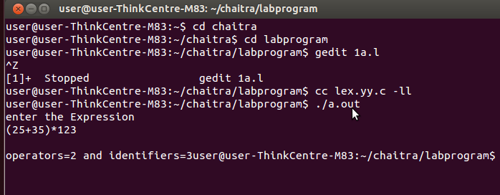

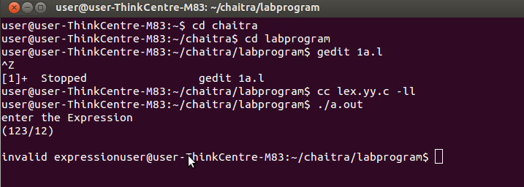

- b. Write YACC program to evaluate arithmetic expression involving operators: +, -, *, and /

LEX PART:

%{

#include "y.tab.h"
extern int yylval;
%}

%%
[0-9]+ {yylval=atoi(yytext);return number;}
. {return yytext[0];}
%%

YACC PART:
%{
#include<stdio.h>
#include<stdlib.h>
int res=0;
%}

%token number
%left '+' '-'
%left '*' '/'

%%
stmt:expr {res=$$;}
;
expr:expr '+' expr {$$=$1+$3;}
|expr '-' expr {$$=$1-$3;}
|expr '*' expr {$$=$1*$3;}
|expr '/' expr {if($3==0)
exit(0);
else $$=$1/$3;}
|'(' expr ')' {$$=$2;}
|number
;
%%
void main()
{
printf(" enter expr\n");
yyparse();
printf("Result is =%d \n",res);
exit(0);
}

yyerror()
{
printf("invalid\n");
exit(0);
}

Output:

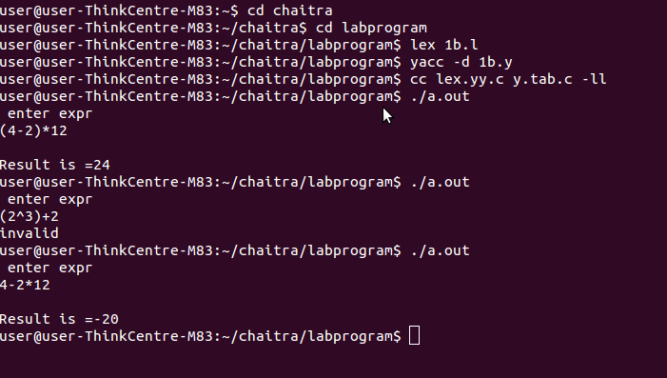

OR

%{
#include<stdio.h>
#include<ctype.h>
#define YYSTYPE double
%}
%token num
%left '+' '-'
%left '*' '/'
%%
lines:lines exp '\n' {printf("\n value =%g \n\n",$2); return 0;}
|lines '\n'
|
;
exp:exp '+' exp {$$=$1+$3;}
|exp '-' exp {$$=$1-$3;}
|exp '*' exp {$$=$1*$3;}
|exp '/' exp {if($3==0.0) printf("divide by zero error");
else
$$=$1/$3;
}
|'('exp')' {$$=$2;}
|'-'exp {-$2;}
|num {$$=$1;}
;
%%
int yylex()
{
char c;
c=getchar();
if((c=='.')||(isdigit(c)))
{
ungetc(c,stdin);
scanf("%lf",&yylval);
return num;
}
return c;
}
int main()
{
printf("enter the expression\n");
yyparse();
return 0;
}

int yyerror()
{
printf("error\n");
return 0;
}

Output:

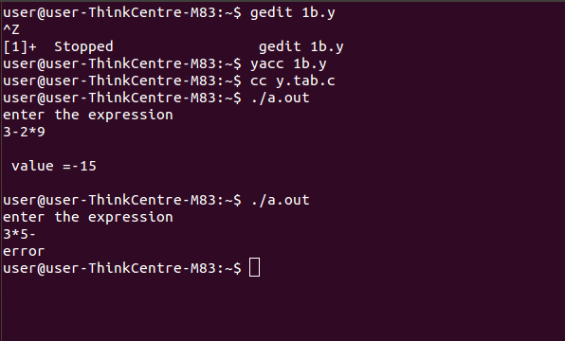

- Develop, Implement and Execute a program using YACC tool to recognize all strings ending with b preceded by n a’s using the grammar an b (note: input n value)
%{
#include<stdio.h>
#include<stdlib.h>
int n,count=0;
%}

%token a b

%%
start:s'\n' {if (count==n)
printf("valid\n");
else
printf("Invalid \n");}

s:a s {count++;}
|b
;
%%

void main()
{
printf("enter the value of n \n");
scanf("%d",&n);
getchar();
printf("enter the string \n");
yyparse();
}

yylex()
{
char c;
c=getchar();
if(c=='a') return a;
if (c=='b') return b;
return c;
}

int yyerror()
{
printf("error \n");
exit(0);
}

Output:

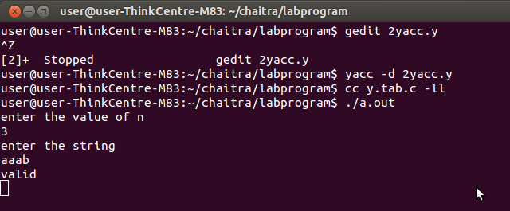
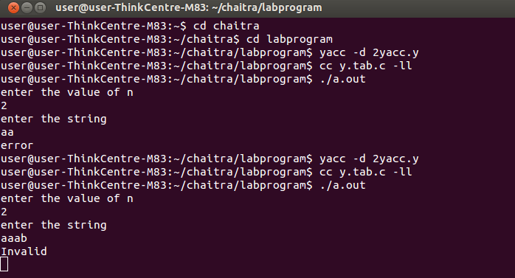
- Design, develop and implement YACC/C program to construct Predictive / LL(1) Parsing Table for the grammar rules: AaBa , BbB | ε. Use this table to parse the sentence: abba$

#include<stdio.h>
//#include<conio.h>
#include<stdlib.h>
#include<string.h>
void main()
{
char M[3][4][10]={"NT/T","a","b","$","A","aBa","Error","Error","B","@","bB","Error"};
char input[20],stack[20],temp[20];
int i,j,k,T,NT,top=-1;
//clrscr();
printf("LL-1 predective parsing table is \n");
for(i=0;i<3;i++)
{
for(j=0;j<4;j++)
printf("%s\t",M[i][j]);
printf("\n");
}
printf("Enter the String to be parsed\n");
scanf("%s",input);
input[strlen(input)]='$';
stack[++top]='$';
stack[++top]='A';
i=j=k=0;
while(stack[top]!='$' || input[i]!='$')
{
if(stack[top]>64 && stack[top]<91)
{
switch(stack[top])
{
case 'A': NT=1; break;
case 'B': NT=2; break;
}
//if stack top is non-terminal
switch(input[i])
{
case 'a': T=1; break;
case 'b': T=2; break;
case '$': T=3; break;
default : printf("\n Error while parsing the string \n");
exit(0);
}
strcpy(temp,M[NT][T]);
if(strcmp(temp,"Error")==0)
{
printf("\n Error while parsing the string \n");
exit(0);
}
else if(strcmp(temp,"@")==0)
top--;
else
{
top--;
for(k=strlen(temp)-1;k>=0;k--)
stack[++top]=temp[k];
}
}
else //if stack top is terminal
{
if(stack[top]==input[i])
{
top--;
i++;
}
else
{
printf("\n Error while parsing the string \n");
exit(0);
}
}
}
printf("String belongs to given grammar \n");
//getch();
}

Output:

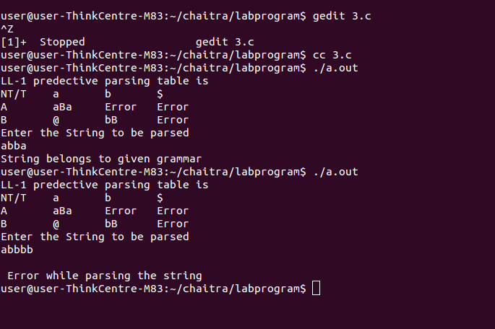

- Design, develop and implement YACC/C program to demonstrate Shift Reduce Parsing technique for the grammar rules: EE+T | T, TT*F | F, F(E) | id and parse the sentence: id + id * id.

#include<stdio.h>
#include<string.h>
int k=0,z=0,i=0,j=0,c=0;
char a[16],stk[15];
void Reduce();
void main()
{
puts("GRAMMAR is \n E->E+E \n E->E*E \n E->(E) \n E->id");
puts("enter input string ");
gets(a);
c=strlen(a);

puts("stack \t input \t action");

for(k=0,i=0; j<c; k++,i++,j++)
{
if(a[j]=='i' && a[j+1]=='d')
{
stk[i]=a[j];
stk[i+1]=a[j+1];
stk[i+2]='\0';
a[j]=' '; a[j+1]=' ';
printf("\n$%s\t%s$\t SHIFT id",stk,a);
Reduce();
}
else
{
stk[i]=a[j];
stk[i+1]='\0';
a[j]=' ';
printf("\n$%s\t%s$\t SHIFT symbols",stk,a);
Reduce();
}
}

}
void Reduce()
{
for(z=0; z<c; z++)
if(stk[z]=='i' && stk[z+1]=='d')
{
stk[z]='E';
stk[z+1]='\0';
printf("\n$%s\t%s$\t REDUCE TO E",stk,a);
j++;
}
for(z=0; z<c; z++)
if(stk[z]=='E' && stk[z+1]=='+' && stk[z+2]=='E')
{
stk[z]='E';
stk[z+1]='\0';
stk[z+2]='\0';
printf("\n$%s\t%s$\t REDUCE TO E",stk,a);
i=i-2;
}
for(z=0; z<c; z++)
if(stk[z]=='E' && stk[z+1]=='*' && stk[z+2]=='E')
{
stk[z]='E';
stk[z+1]='\0';
stk[z+1]='\0';
printf("\n$%s\t%s$\t REDUCE TO E",stk,a);
i=i-2;
}

for(z=0; z<c; z++)
if(stk[z]=='(' && stk[z+1]=='E' && stk[z+2]==')')
{
stk[z]='E';
stk[z+1]='\0';
stk[z+1]='\0';
printf("\n$%s\t%s$\t REDUCE TO E",stk,a);
i=i-2;
}
}

Output:

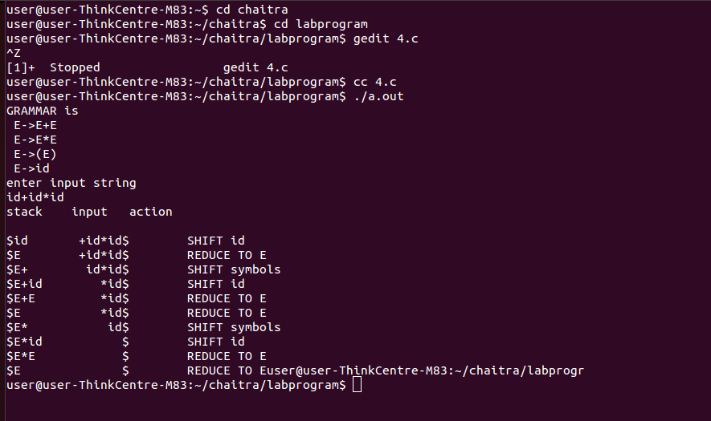

- Design, develop and implement a C/Java program to generate the machine code using Triples for the statement A = -B * (C +D) whose intermediate code in three-address form:T1 = -B

T2 = C + D

T3 = T1 + T2 A = T3

#include<stdio.h>
#include<stdlib.h>
#include<string.h>
#include<ctype.h>
char op[2],arg1[5],arg2[5],result[5],eq[2];
void main()
{
FILE *fp1;
fp1=fopen("input3.txt","r");
while(!feof(fp1))
{
fscanf(fp1,"%s%s%s%s%s",result,eq,arg1,op,arg2);
if(strcmp(arg1,"T3")==0)
{
printf("\nMOV R0,%s",arg1);
printf("\n MOV %s,R0\n",result);
}
else
if(strcmp(op,"+")==0)
{
printf("\n MOV R0,%s",arg1);
printf("\n ADD R0,%s",arg2);
printf("\n MOV %s,R0",result);
}
else
if(strcmp(op,"*")==0)
{
printf("\n MOV R0,%s",arg1);
printf("\n MUL R0,%s",arg2);
printf("\n MOV %s,R0",result);
}
else
if(strcmp(op,"-")==0)
{
printf("\n MOV R0,-%s",arg2);
printf("\n MOV %s,R0",result);
}
}
fclose(fp1);
}

Output:

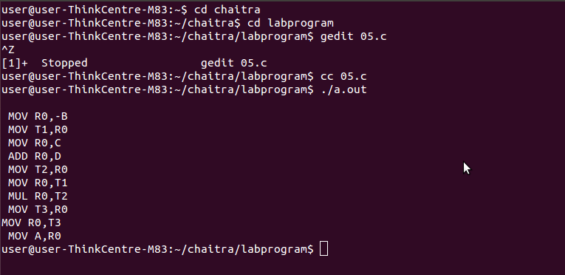

- a) Write a LEX program to eliminate comment lines in a C program and copy the resulting program into a separate file.
%{
#include<stdio.h>
#include<stdlib.h>
I nt l=0;
%}

%%
"/*"[^*]*"*/" l++;
"//".* l++;
%%
int main()
{
yyin=fopen("new.c","r");
yyout=fopen("new1.c","w");

yylex();

fclose(yyin);
fclose(yyout);
printf("no of comment lines are =%d \n",l);
}
Output:

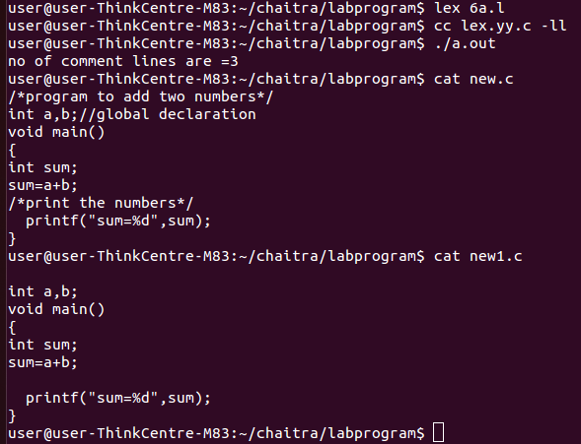
- b). Write YACC program to recognize valid identifier, operators and keywords in
the given text (C program) file.
LEX PART:

%{

#include "y.tab.h"
extern int yylval;
%}

%%
int|char|float|if|else|printf {printf("keyword is - %s \n",yytext); return key;}
[a-zA-Z][a-zA-Z0-9]* {printf("identifier is- %s \n",yytext); return id;}
[*+-/(),<>=] {printf("operator is - %s \n",yytext); return op;}
[0-9]+ {printf("number is- %s \n",yytext); return num;}
. ;
\n ;
"\"".*"\"" {printf("string is- %s \n",yytext);}
%%
YACC PART:
%{
#include<stdio.h>
#include<stdlib.h>
int k=0,i=0,n=0,opr=0;
extern FILE *yyin;
%}

%token num id op key

%%
s: key {k++;}
| op {opr++;}
| num {n++;}
| id {i++;}
| id s {i++;}
| num s {n++;}
| op s {opr++;}
| key s {k++;}
;
%%
void main()
{
yyin=fopen("input.c","r");
while(!feof(yyin))
yyparse();

printf(" \n key=%d and op=%d and id=%d and num=%d",k,opr,i,n);
}

yyerror()
{
printf("invalid\n");
exit(0);
}
Output:

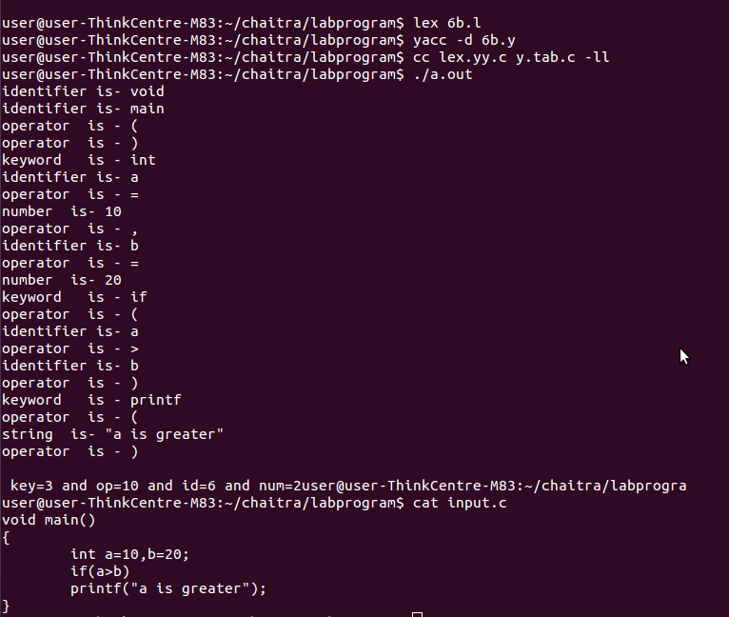
- Design, develop and implement a C/C++/Java program to simulate the working of Shortest remaining time and Round Robin (RR) scheduling algorithms. Experiment with different quantum sizes for RR algorithm

#include<stdio.h>

int n,qtum,pid[10],a[10],b[10],tt[10],avg[10];
int flag[10],flag1[10],swt=0,stat=0,rbt[10],i_total_burst_time=0;
float f_avg_turn_arnd_time=0.0,f_avg_wait_time=0.0;

rr()
{
int ch;
int st[10];
int i,count=0,temp,sq=0;
printf("enter the no. of processors\n");
scanf("%d",&n);
printf("enter the burst time\n");
for(i=0;i<n;i++)
{
pid[i]=i+1;
scanf("%d",&b[i]);
}
printf("enter the quantum:");
scanf("%d",&qtum);
for(i=0;i<n;i++)
{
st[i]=b[i];
}
while(1)
{
for(i=0;i<n;i++)
{
temp=qtum;
if(st[i]==0)
{
count++;
continue;
}
if(st[i]>qtum)
st[i]=st[i]-qtum;
else
if(st[i]>=0)
{
temp=st[i];
st[i]=0;
}
sq=sq+temp;
tt[i]=sq;
}
if(n==count)
break;
}
printf("\n process id burst time wait time turn around time \n");
for(i=0;i<n;i++)
{
avg[i]=tt[i]-b[i];
printf("%d\t\t%d\t%d\t%d",i+1,b[i],avg[i],tt[i]);
printf("\n");
}
for(i=0;i<n;i++)
{
swt=swt+avg[i];
stat=stat+tt[i];
}
f_avg_wait_time=(float)swt/n;
f_avg_turn_arnd_time=(float)stat/n;
printf("\n\n Average waiting time is %f\n Average turn around time is %f\n",f_avg_wait_time,f_avg_turn_arnd_time);
return 1;
}

int srtf()
{
int ch;
int a[10],b[10],x[10],i,j,smallest,count=0,time=0,n;
double avg=0,tt=0,end;
printf("enter the no. of processes:\n");
scanf("%d",&n);
printf("enter arrival time\n");
for(i=0;i<n;i++)
scanf("%d",&a[i]);
printf("enter the burst time\n");
for(i=0;i<n;i++)
scanf("%d",&b[i]);
for(i=0;i<n;i++)
x[i]=b[i];
b[9]=9999;
for(time=0;count!=n;time++)
{
smallest=9;
for(i=0;i<n;i++)
{
if(a[i]<=time && b[i]<b[smallest] && b[i]>0)
smallest=i;
}
b[smallest]--;
if(b[smallest]==0)
{
count++;
end=time+1;
avg=avg+end-a[smallest]-x[smallest];
tt=tt+end-a[smallest];
}
}
printf("\n Average waiting time=%lf\n",avg/n);
printf("Average turn around time=%lf\n",tt/n);
return 0;
}

int main()
{
int i,ch;
printf("1.SRTF\n");
printf("2.RR\n");
printf("3.exit\n");
printf("enter the choice\n");
scanf("%d",&ch);
switch(ch)
{
case 1:srtf();
break;
case 2:rr();
break;
case 3:return 1;
}
return 1;
}

Output:

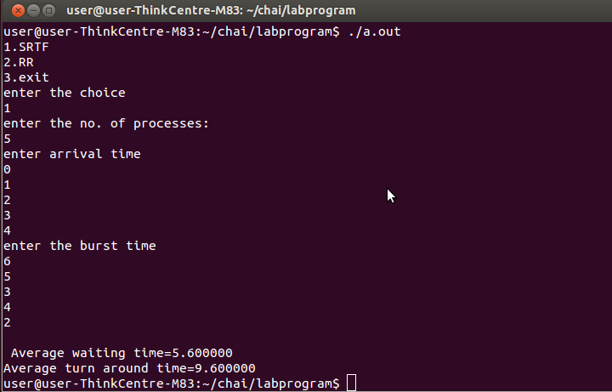

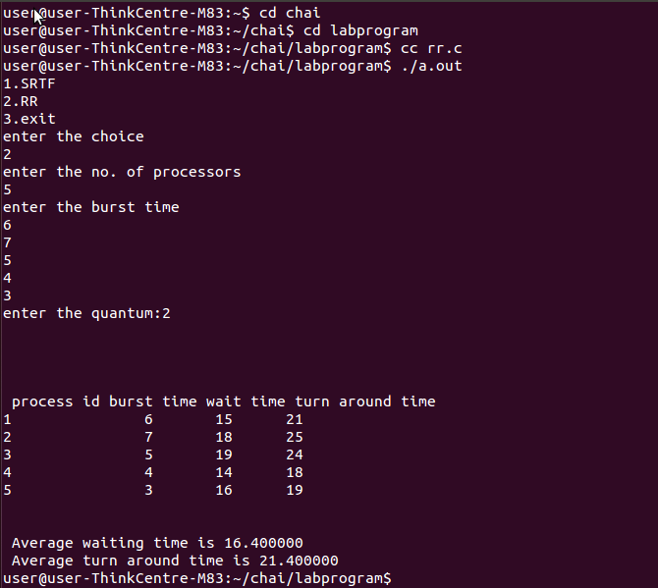

- Design, develop and implement a C/C++/Java program to implement Banker’s algorithm. Assume suitable input required to demonstrate the results.

#include<stdio.h>

struct process
{
int allocation[6],max[6],need[6],finished, request[6];
} p[10];

int avail[6], sseq[10], ss=0, check1=0, check2=0, n, pid, work[6];
int nor, nor_i;

void main()
{
int safeseq(void);
int tj,ch,i=0,j=0,k,pid,ch1;

printf("\n Enter number of processes : ");
scanf("%d",&n);

printf("\n Enter the Number of Resources : ");
scanf("%d", &nor);

printf("\n Enter the Available Resources : ");
for(j=0;j<n;j++)
{
for(k=0; k<nor; k++)
{
if(j==0)
{
printf("\n For Resource type %d : ",k);
scanf("%d", &avail[k]);
}

p[j].max[k]=0;
p[j].allocation[k]=0;
p[j].need[k]=0;
p[j].finished=0;
p[j].request[k]=0;
}
}

printf("\n Enter Max resources for all processes\n");
for(i=0;i<n;i++)
{
for(j=0; j< nor; j++)
{
scanf("%d",&p[i].max[j]);
}
}

printf("\n Enter Allocated resources for all processes\n");
for(i=0;i<n;i++)
{
for(j=0;j<nor;j++)
{
scanf("%d",&p[i].allocation[j]);

if(p[i].allocation[j]>p[i].max[j])
{
printf("\n Allocation should be less < or == max");
j--;
}
else
p[i].need[j]=p[i].max[j]-p[i].allocation[j];
}
}
if(safeseq()==1)
{
printf("\n The System is in Safe state\n ");
}
else
printf("\n The System is Not in safe state\n ");
printf("\n Need\n");
for(i=0;i<n;i++)
{
for(j=0;j<nor;j++)
printf(" %d ",p[i].need[j]);
printf("\n");
}
}

int safeseq()
{
int tk,tj,i,j,k;
ss=0;
for(j=0; j<nor; j++)
work[j] = avail[j];
for(j=0;j<n;j++)
p[j].finished=0;
for(tk=0; tk<nor; tk++)
{
for(j=0;j<n;j++)
{
if(p[j].finished==0)
{
check1=0;
for(k=0; k<nor; k++)
if(p[j].need[k]<=work[k])
check1++;
if(check1== nor)
{
for(k=0;k< nor;k++)
{
work[k]= work[k]+p[j]. allocation[k];
p[j]. finished=1;
}
sseq[ss]=j;
ss++;
}
}
}
}
check2=0;
for(i=0;i<n;i++)
if(p[i].finished==1)
check2++;
if(check2>=n)
{
printf("The Safe Sequence is\t :");
for(tj=0;tj<n;tj++)
printf("%d, ", sseq[tj]);
return 1;
}
return 0;
}

Output:

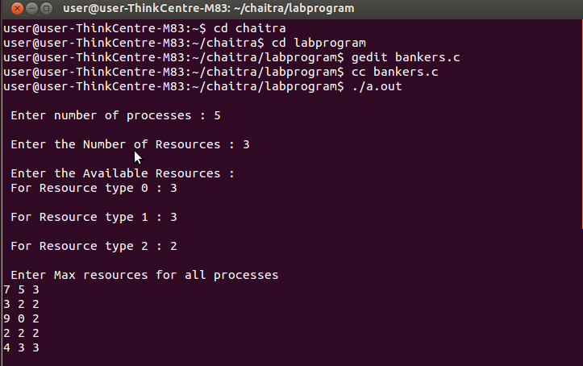
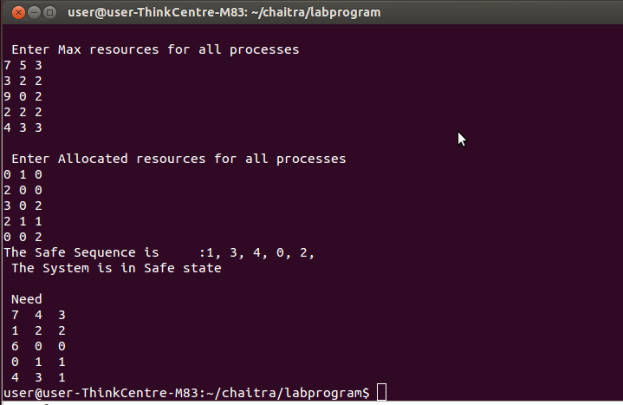

- Design, develop and implement a C/C++/Java program to implement page replacement algorithms LRU and FIFO. Assume suitable input required to demonstrate the results.

LRU:
#include<stdio.h>
#include<stdlib.h>

char frm[10],s[20];
void main()
{
int m=0,k,f=3,l,i=0,flag=0;
printf("enter the frame size\n");
scanf("%d",&f);
printf("enter the characters(or)no of pages required\n");
scanf("%d",&l);
printf("enter the 10 characters\n",l);
scanf("%s",s);
printf("page frame res\n");
for(i=0;i<l;i++)
{
flag=0;
for(k=0;k<f;k++)
if(s[i]==frm[k])
{
flag=1;
break;
}
if(m<f && flag==0)
{
frm[m]=s[i];
m++;
printf("%c\t%s\t page fault\n",s[i],frm);
}
else if(flag!=1)
{
for(k=0;k<m-1;k++)
frm[k]=frm[k+1];
frm[k]=s[i];
printf("%c\t%s\t page fault \n",s[i],frm);
}
else
{
for(k=k;k<m-1;k++)
frm[k]=frm[k+1];
frm[k]=s[i];
printf("%c\t%s\t no page fault \n",s[i],frm);
}
}
}

FIFO:
#include<stdio.h>
#include<stdlib.h>

char frm[10],s[20];
void main()
{
int m=0,k,f=3,l,i=0,flag=0;
printf("enter the frame size\n");
scanf("%d",&f);
printf("enter the characters(or)no of pages required\n");
scanf("%d",&l);
printf("enter the 10 characters\n",l);
scanf("%s",s);
printf("page frame res\n");
for(i=0;i<l;i++)
{
flag=0;
for(k=0;k<f;k++)
if(s[i]==frm[k])
{
flag=1;
break;
}
if(m<f && flag==0)
{
frm[m]=s[i];
m++;
printf("%c\t%s\t page fault\n",s[i],frm);
}
else if(flag!=1)
{
for(k=0;k<m-1;k++)
frm[k]=frm[k+1];
frm[k]=s[i];
printf("%c\t%s\t page fault \n",s[i],frm);
}
else
{
printf("%c\t%s\t no page fault \n",s[i],frm);
}
}
}

Output:
LRU:
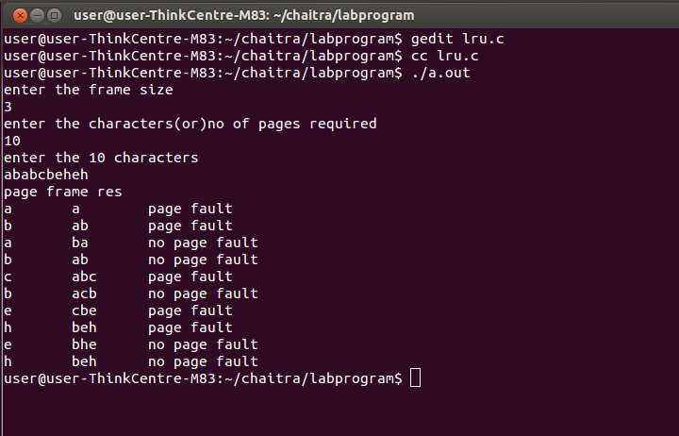
FIFO:

